**FUNDAMENTAL OF MANAGEMENT**



**PROJECT:**

**MCB BANK**

**Group number 2**

**Group Members:**

* Ibrar Babar (19P-0104)
* Asjid Tahir (p19-0085)
* Usman Manzoor (p19-0068)
* Umar Farooq (p19-0065)

**Organizational Structure OF MCB (Bank)**

The arrangement of jobs within **MCB bank** in all over the Pakistan is highly appreciated.

The SIX key elements of MCB (Organizational Structure) are as follow…

**Work Specialization:**

Division of work in MCB bank is done very great fully all over the Pakistan. Managers of every branch of MCB have to do there work properly.

In Peshawar Branch, the **Manager** of MCB bank is very kind to all workers.

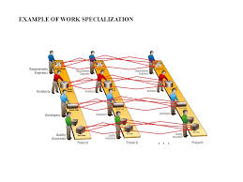

2nd the **Operational manager** of

MCB bank is very kind to all there

employees how are working under her.

Every employee have do there

work properly including cashiers,

customer dealers, Tea boys etc.

In other words we can say that the work specialization in MCB bank is very appreciated.

**Departmentalization:**

**Structure of Finance/Accounting Department of MCB Bank**

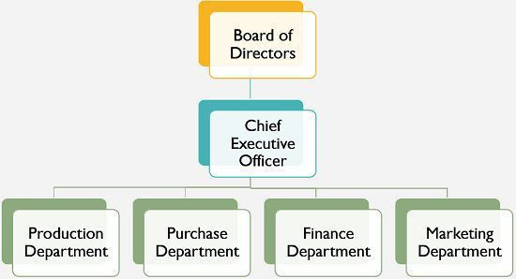 MCB Bank has separate departments for accounts and finance. Both of these departments are controlled by CFO. Accounts Department has further Accounting and Operation Department, Accounting & Audit Department and Control Department whose officers report to CFO.

MCB bank have separate managers of

Financial department, who have to

manage all the financial issue of customers.

They also have to Advice institutions

on high net worth individual customer

on investing funds, managing assets, reorganizations, raising capital.

**Remittances Department**

The remittances department transfers the funds from one bank to other bank and from one place to another place. ATM and online banking has also effected the remittances department and increased its efficiency.

**Account Opening Department**

The opening of an account is the establishment of banker customer relationship. Before a banker opens a new account, the banker should determine the prospective customer’s integrity, respectability, occupation and the nature of business by the introductory references given at the time of account opening.

**Cash Department**

Cash department performs the following functions.

**Receipt**

The money, which either comes or goes out from the bank, its record should be kept. Cash department performs this function. The deposits of all customers of the bank are controlled by means of ledger accounts. Every customer has its own ledger account and have separate ledger cards.

**Payments**

It is a banker’s primary contract to repay money received for this customer’s account usually by honoring his cheques.

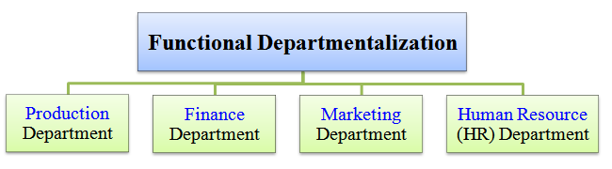

**Advances Department**

Advances department is one of the most sensitive and important departments of the bank. The major portion of the profit is earned through this department. The job of this department is to make proposals about the loans.

**Chain of Command:**

Important changing in structure of MCB bank have to be done by Top level managers of MCB. First the rule have to be pass by the **CEO** (Imran Maqsood) & **Chairmen** (Mian Muhammad Mansha), and then furthur the rule have to pass by other low level managers.

**System and Processes ,** The strategy adopted should be closely linked with the system and processes. It means that daily routine activities being carried out in an office should be systematic and well organized like capital budgeting system.

**Style (Leadership/Management Style)** There are two major kinds of style in leadership or management; transactional/ professional and transformational. Transactional, also known as professional leadership style

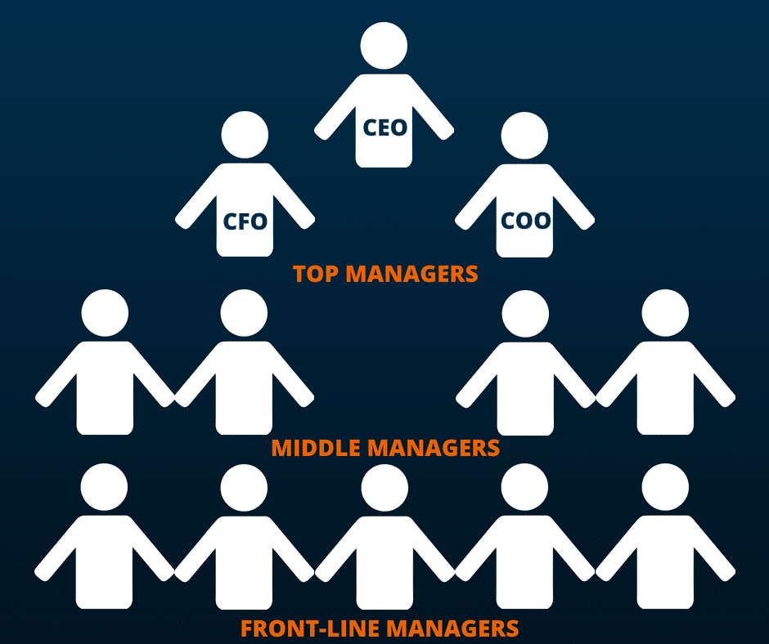 **Staff**, As the name ‘staff’ suggests, many people of different qualification, cadre, skills and expertise working in an

organization, the strategy

is devised in order to choose

and attract such individuals who

are really needed by the relevant business.

**Span of Control:**

The controlling system of MCB is arranged very carefully.  
Like the manager have to **control the internal process** of Bank.

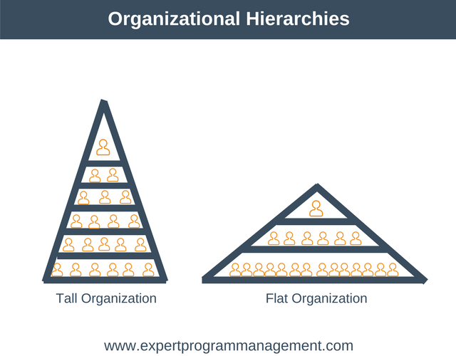

Lot of **work load**, but management provide time to time training for how to **handle work** load and provide high quality quick service to customers.  
Every staff member having a freedom regarding their work.

And all employees and other worker in the bank like tea boys etc, they can all be controlled by operational manager.

**Centralization and Decentralization:**

**Centralized banks** are restricted to brick and mortar locations, bureaucracy and many people to pay.

**Decentralized banks** do not have

these strings attached and

can easily scale globally. A global economy will be stimulated through

global **banking**.

MCB Bank is totally Centralize, Because,  there is a hierarchy of formal authority for making all the important decision for the organization.

**Employees Empowerment:**

MCB is an equal opportunity employers for everyone who are experienced in related field.

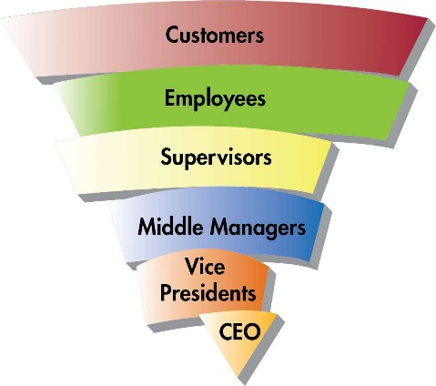   
MCB provides excellent opportunities

to their employees and have good

chances of growth in career & have an

excellent culture and good place to work

for everyone.

**MCB**  provide their **employees** with a certain degree of autonomy and control in their day-to-day activities

This can include having a voice in process

improvement, helping to create and

manage new systems and tactics,

and running smaller departments with

less oversight from higher-level management.

A key principle of employee empowerment

is providing employees the means for

making important decisions and helping ensure those decisions are correct.

**Formalization:** MCB’s policies, procedures, job descriptions, and rules are written and explicitly articulated. **Formalized** structures are those in which there are many written rules and regulations.

 These structures control employee behavior using written rules, so that employees have little autonomy to decide on a case-by-case basis.

An advantage of formalization is that it makes employee behavior more predictable.

Whenever a problem at work arises, employees know to turn to a handbook or a procedure guideline. Therefore, employees respond to problems in a similar way across the organization; this leads to consistency of behavior.

**CONCLUSION:**

**MCB**  is actually an organization in which every work have to be divide to the workers of bank equally according to their position.

The arrangement of every department is done by special separate managers, Like the financial department have separate managers etc.

MCB Bank has separate departments for accounts and finance, The remittances department, opening of an account department, cash department etc.

Important decisions and changing in structure of MCB bank have to be done by Top level managers of MCB.

The strategy adopted should be closely linked with the System and Processes.

Manager have to **control the internal process** of Bank.

Every staff member having a freedom regarding their work.

MCB Bank is totally Centralize, Because,  there is a hierarchy of formal authority for making all the important decision for the organization

**Motivation:**



**Maslow Hierarchy of Needs:**

In our Daily lives in the ever-challenging balance between our professional lives vs. Personal life our needs and wants are been more completed and compulsory on the way to our journey. In this we will take a look at Maslow’s hierarchy (or pyramid) of needs more in-depth to answer these questions.

Discover everything that needs to know about motivation through this theory by further relating to an organization on reality.

**Figure:**

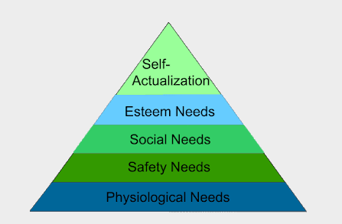

**MacGregor’s Theories X and Y:**

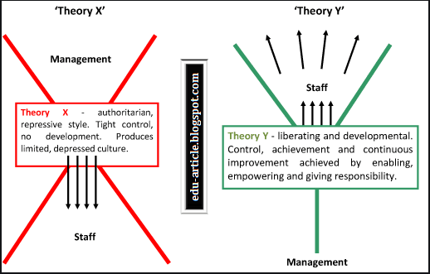

MCB Internet Banking offers you the convenience to manage and control your bank account and finances; whenever and wherever you want!

MCB Internet Banking is:

Smart

Secure

**What we are offer:**

MCB Internet banking is available to Retail and Corporate* customers and it offers the following services:

Account summary of all your listed accounts

Mini-statements (last 10 transactions) of each of your listed accounts

Statement-by-period of each of your listed accounts, based on the period specified

Ability to customize your homepage according to your needs and requirements

Mobile browser compatibility so you can carry out transactions on the go

Enhanced security by dual security mechanism that authenticates you at different levels

Immediate or scheduled transfer of funds between your own accounts, as well as to third-party accounts within MCB Bank

Scheduling of one-time as well as recurring payments. Option for full or partial payment based on the payment conditions

Maintain beneficiaries of frequent payees

Cheese book request for any of your listed accounts (online branches only)

Exchange Rate Inquiry

Mail box to request for Linking, De-linking of Account & Credit Card

Alerts on Login, Account status, Funds transfer & Bill payments on your Mobile and Email.

**Herzberg’s Two-Factor Theory:**

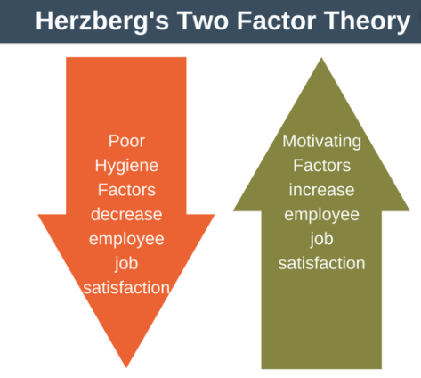

The **two**-**factor theory** (also known as **Herzberg's motivation-hygiene theory** and **dual**-**factor theory**) states that there are certain **factors** in the workplace that cause job satisfaction while a separate set of **factors** cause dissatisfaction, all of which act independently of each other.

These factors are:

**Motivators:** Which can encourage employees to work harder.

**Hygiene factors**: These won’t encourage employees to work harder but they will cause them to become unmotivated if they are not present.

Note:

Herzberg’s Motivation Theory model goes by a number of different names, including Two Factor Theory, Herzberg’s Motivation-Hygiene Theory, and Duel Structure Theory. We will use these terms interchangeably in this article.

Frederick Herzberg developed the model in 1959. He did this by interviewing over 200 professionals. The interviews delved into when the interviewees were at their most and least happy with their jobs.

**Motivation and Goals:**

We at MCB Bank Limited believe that every employee is unique and possesses distinctive talents that we value and nurture Therefore, at MCB Bank, we inspire every individual to play a significant role in our continued success by creating maximum economic value for our clients and shareholders, while maintaining the highest human values and principles.

MCB Bank is one of the leading financial services providers in Pakistan and as one of the largest and oldest banking entities in the country we strive for growth and change as well.

Our goal is to create and promote long term relationships with our customers by catering to all their financial needs, including traditional banking services, insurance and investment advisory, coupled with an exceptional level of customer service.

Our objective at MCB Bank is to ensure that we have motivated, professional and customer-centric employees on board who help us deliver the promise of being the ‘most credible bank’ across the industry.

**Imran Cabool  
President & CEO  
MCB Bank Limited**

**Designing Motivating Jobs:**

At MCB Bank Limited, we value individuals who enjoy the challenges of solving problems and take initiatives to continuously learn and think ‘out of the box’.

Though the Bank continues to evolve and change, the key to our success remains constant; we focus on customer needs.

Spirit of innovation, and broad range of expertise combined with technological power and financial strength delivered by diverse, highly skilled professionals across the world.

**Job Characteristics Model (JCM)**

Job Satisfaction and Motivation in Banking Industry in Pakistan

**Nadeem Bhatti** (Head of Faculty, North American College, Toronto, Ontario, Canada)

**Anwar Ali Shah G. Syed** (Chancellor-Daddy-Campus, University of SindhJamshoro, Pakistan)

**F. M. Shaikh** (SZABAC-Dokri-Sindh, Pakistan)

**Job Satisfaction and Motivation in Banking Industry in Pakistan**

The current research investigates the predictors of job satisfaction and motivation in banking industry of Pakistan. Data were collected from the 200 bankers of Middle and Upper management Level by using cross Sessional method, and randomly selected from 6 banks, which includes, Habib Bank Limited( HBL).

**Current Issues in Motivation:**

**Planning Change in an Organization; MCB Bank Limited, Pakistan**

This paper is primarily based on a case study of a leading bank in Pakistan, that is, MCB Bank Ltd. Four established change models have been applied to the bank to find out how a change comes in/ is brought in, managed, and how it affects organizational environment and its stakeholders, particularly customers and employees.

**The Four Established Models**

The Four Established Models are;

Strategy

Structure

System and Processes

Staff

**LEADERSHIP IN MANAGEMENT:**

Leadership is the action of leading people in an organization towards achieving goals. A leader sets a clear vision for the organization, motivates employees, guides employees through the work process and builds morale. Leadership involves leading others toward achieving clear goals.

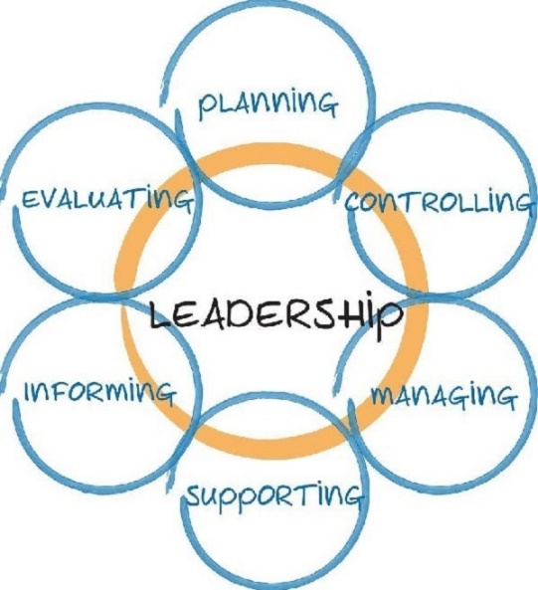**Major Roles of leadership:**

* Vision.
* Focus.
* Influence.

**Leadership Functions:**

* Setting Goals:
* Organizing
* Initiating Action:
* Co-Ordination
* Direction and Motivation:
* Link between Management and Workers:
* It Improves Motivation and Morale:
* It Acts as a Motive Power to Group Efforts.

**Leadership vs. Management:**

A leader is a person who has a vision which goes towards attaining a goal or fulfilling the purpose and the strategy of an organization which can be used to obtain that goal. In comparison a manager is a person who implements said vision. In practice the leader chooses a direction for the future of a company. The manager then creates a plan and monitors the results gained from implementing the plan to

eventually carry the leader's vision into effect**. “It is generally the case that a 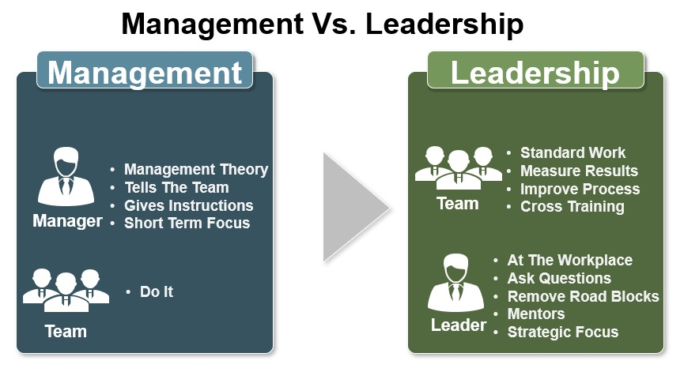leader is also a manager, but not all managers are leaders”.**

**Transactional leadership Vs Transformational Leadership:**

Transactional leadership works within set established goals and organizational boundaries, while a transformational approach challenges the status quo and is more future-oriented. Transactional leadership emphasizes organization, performance evaluation and rewards, and is task- and outcome-oriented.

**Transformational Leadership is good?**

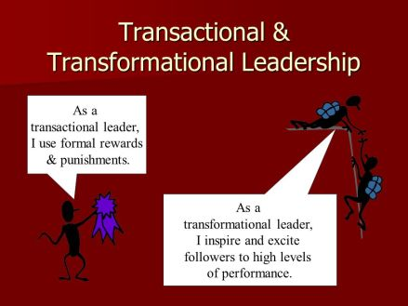A transformational leadership style inspires employees to strive beyond required expectations to work toward a shared vision, whereas transactional leadership focuses more on extrinsic motivation for the performance of specific job tasks. Learning to balance these styles can help leaders reach their full potential.

**Ethical leadership of Bank:**

An ethical leader has an accountability to develop a good provide model in which followers can do extremely well. Effective ethical leaders therefore have a significant influence on the employee engagement in day to day job.

 The problems have much to do with the lack of ethical leadership practices of banks' top management, precisely what steps are being taken to bring to heel the rampant corruption was not outlined.

The whole country knows about non-performing loans (NPLs), loan scams and forgery.

But it is good to know that the BB has pinpointed that ethical practices must constitute the guiding principles for a bank's leadership if good governance is to return to our banking sector.

This must stop if the banks are to avoid the NPL trap. Again, while we fully agree with this statement, it is hardly a revelation and one must ask precisely what BB is going to do about the many malpractices that have engulfed the banking sector both state-owned commercial and privately-owned banks.

**Cross-Culture Management:**

Cross-cultural management is the study of management in a cross-cultural context. It includes the study of the influence of societal culture on managers and management practice as well as the study of the cultural orientations of individual managers and organization members. The cross-cultural leadership posit that it does not always hold that a leader who happens to be fruitful and efficient in one country to do the same in a different country altogether.

Traits of an Effective Cross-Cultural Leader. Many partners and employees have in any one given time felt challenged while working with someone who was different from them, one that hailed from another region or country.

The business world is increasingly being dynamic and flat calling for leaders to work effectively in cross-cultural environments by becoming culturally aware, knowledgeable, and open-minded about how to effectively lead and inspire people across cultures.

* **Leaders who Raise Awareness and Cultural Sensitivity:**

It is essential for leaders to be comprehensively aware and mindful of cultural differences. Cultural sensitivity helps a leader in understanding and being patient in dealing and handling employees from all walks of life. This call for one to fit in someone else’s shoes in the sense that he is aware of the challenges these employees will have to cope up with as they continue with their daily tasks.

* **Leaders who Open Opportunity Doors with an Open Mind:**

As much as globalization is being experienced, phrases such as; “Their culture is weird” and “Things haven't handled that way in my country” among others have not gone unnoticed in leaders’ comments. Others prefer interacting and working with people, they have something in common. Leaders ought to understand that opening new doors of opportunity and growing the business is not all that is required, but also keeping an open mind while opening those doors.

Gender Differences in Leadership

**Gender Differences in Leadership Management:**

Gender Differences in Leadership

Gender affects leadership in many aspects. Whether men and women lead in a different way is still a highly debated issue. However, the major effect of gender on leadership is that women are presumed to be less competent and less worthy to hold leadership positions. Leadership style depends on a number of factors, where gender is one of them. Leaders adapt to expectations based on people’s categorization of them as male or female. Those expectancies are derived from traditional gender roles – roles in the society, in the family, and in paid employment A contradictive study indicates that the only difference between male and female leadership lies in the decision-making process, while differences in other areas such as task orientation, motivation, and leadership styles are not significant enough to warrant any statement that leadership varies between genders.

